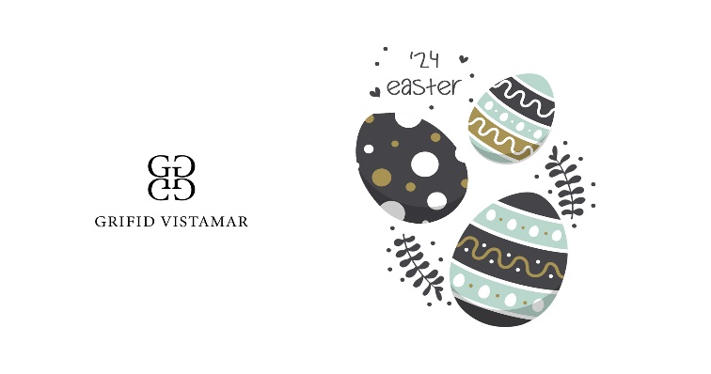1st May/Easter Hotel Fact Sheets
Accommodation
- Period for stay – 30.04.24-06.05.24
- Check in time from 14:00, check out till 11.00
- Check-in starts with lunch and check – out ends with breakfast
- Early check-in after 10.00 a.m. and/or late check-out after 11.00 noon - 49.00 BGN per room
- Parking place – limited, against charge – 20.00 BGN per day;
Garage (GRIFID Bolero) – 30.00 BGN per day
- In room safe – free of charge
- Free in room Wi-Fi connection

Restaurants and Bars – ULTRA ALL INCLUSIVE
- Buffets for breakfast (07.30-10.00), lunch(12.30-15.00) and dinner (18.00-21.00)
- Daily special highlights for breakfast
- Festive Easter Lunch Buffet on 05.05.2024 with Easter Eggs, Easter Bread, Roast Lamb, Green Spring Salad, Easter Muffins for Children
- Different theme buffet for dinner every evening
- Continental breakfast – A la carte (10.00 – 12.00)
- Pastry shop with variety of cookies, cakes, creams (14.00-17.00)
- Snack restaurant with Pizza, Pasta, Sandwiches, Fruit (14.30-17.00)
- One a la carte dinner per stay (reservation required) (18.30-21.30h.) Italian and Classic A la Carte Restaurants
- Selected Local and International Alcoholic and Non-alcoholic Drinks from 10.00 till 01.00h., offered in the hotel bars
- Daily refilled mini bar with beer, soft drinks and mineral water
Animation and fun
- Every day the customers can join and enjoy our sports entertainment program with the professional entertainment team of GRIFID HOTELS.
- Multipurpose playground for football, volleyball, basketball, tennis
- Sport & Fun: SPECIAL PROGRAM DESIGNED FOR EGG-CELLENT MOMENTS
- Well Fit: Fitness, Dance Aerobic, Pilates, Stretch & Relax, Zumba, Aqua Gym Body styling, Aqua Fit
- Dance lessons: Salsa, Bachata, Cha-Cha
- Every day- evening shows and entertainment program.

- 05.05.2024 – Easter special
- Easter celebration ceremony for health and prosperity with Priest
- Discotheque and funny activities every night

For Children:
- Mini club with GRIFID children animators and daytime entertainment program for guests aged 4-12 with variety of activities:
- Popular Easter Activities: Easter Coloring Pages, Easter Clip Art - Easter Eggs, Bunnies and More, Jeweled Easter Eggs, Napkin Applique Easter Eggs,
- Top Bunny Crafts: Bunny Ears for Kids, Bunny Party Hats, Easter Bunny Bag, Easter Pom-pom Bunny
- Baskets of Fun: Egg Hunt Basket, Easter Bunny Basket
- Easter Decorations: Easter Crafts, Egg Carton Flowers, Easter Egg Garland, Paper Napkin Easter Decorations
- Games & Activities: Special Activities for the Whole Family plus: Games and Competitions: Easter Egg Race, Minute to Win it Games, Easter Bunny Party, Easter Word Puzzles, Egg Toss, Peter Cottontail Game, Easter Olympic Games, Giant Egg Hunt
- Mini Disco & Funny games every day from 20 h.
- Opening hours for the mini club – 10.00-12.30 and 15.00-17:30

Sports and relaxation
- Open access fitness centre in GRIFID Vistamar with modern Techno Gym® equipment
- Heated indoor swimming pool
- Complimentary sun beds and pool towels
- Beauty salon (at extra charge)
- Steam bath, sauna, Wellness and beauty treatments, Classic and variety of massages (at extra charge)

